Alliance School of Advanced Computing
Course Name: | Graph Analytics
Course Code: | E1ITC302
Assignment No: | Assignment 5: Graph Analytics: University Course Registration System Using Neo4j
Name of the Student: | Kaaysha Rao
Registration Number: | 2411021060775

A. Title of The Problem:
Graph Analytics: University Course Registration System Using Neo4j
B. Problem Statement in details:
A university wants to develop a graph database to manage students, faculty members, courses, and academic departments. The system should represent these entities as nodes and their associations as relationships. You are required to implement the system using Neo4j and the Cypher query language. The sample data and relationships are provided below. Your task is to write the Cypher code to create the nodes, assign properties, establish relationships, and answer the given questions through queries.
1. Sample Data Entities:
• Student: (S101: Aarav Sharma, Sem 5, aarav@univ.edu), (S102: Priya Das, Sem 5, priya@univ.edu), (S103: Rahul Verma, Sem 3, rahul@univ.edu), (S104: Sneha Roy, Sem 3, sneha@univ.edu), (S105: Arjun Patel, Sem 5, arjun@univ.edu)
• Faculty: (F101: Dr. Meera Sen, Assoc Prof, Database Systems), (F102: Dr. Amit Roy, Asst Prof, Data Analytics)
• Courses: (CS301: Graph Analytics, 3 Cr, Advanced), (CS302: DBMS, 4 Cr, Core), (CS303: Data Mining, 3 Cr, Advanced), (CS304: Big Data Analytics, 4 Cr, Advanced), (CS305: NoSQL Databases, 3 Cr, Core)
• Departments: (D101: Computer Science, Block A), (D102: Information Technology, Block B)
2. Relationships to Establish:
• ENROLLED_IN: (Student → Course) with relationship properties: semesterEnrolled, grade ('Not Published')
• TEACHES: (Faculty → Course) with relationship property: academicYear ('2026-27')
• BELONGS_TO: (Student → Department)
• OFFERS: (Department → Course)
3. Programming Tasks (Part A: Tasks 1 to 6; Part B: Tasks 7 to 14): Perform graph creation, validation, and analytical multi-hop filtering queries using Cypher.
C. HackerRank/Leetcode Link of the problem (If applicable):
N/A (Neo4j Graph Database Laboratory Assignment & Practical Assessment)
D. Student's Github link of report and code upload, along with the readme file:
https://github.com/KaayshaRao20/University-Course-Registration-System-Neo4j
E. Solution Steps/Algorithm:
• Step 1: Graph Model & Entity Identification: Identify core entities as graph node labels (:Student, :Faculty, :Course, :Department) and semantic interconnections as directed relationship types ([:ENROLLED_IN], [:TEACHES], [:BELONGS_TO], [:OFFERS]).
• Step 2: Cypher Node Creation: Write declarative CREATE queries in Cypher to instantiate all 14 nodes, setting their unique primary keys (studentId, facultyId, courseCode, deptId) and entity properties.
• Step 3: Relationship & Edge Attribute Assignment: Establish directional edges using MATCH and CREATE clauses. Attach edge-specific attributes including semesterEnrolled and grade on [:ENROLLED_IN], and academicYear on [:TEACHES].
• Step 4: Schema Verification & Inspection: Inspect the full graph topology via `MATCH (n)-[r]->(m) RETURN n, r, m;`. Aggregate node counts grouped by labels and confirm relationship cardinalities and directionality.
• Step 5: Query Execution for Information Retrieval: Formulate targeted Cypher queries for filtering by property values (Semester = 5, Credits > 3), pattern-matching paths (Faculty teaching courses, Student department memberships, Department offered courses), and complex multi-relationship conjunctions (students enrolled in Graph Analytics and another course).

F. Code developed:
The comprehensive Cypher scripts implemented for Part A (Graph Creation & Verification) and Part B (Retrieval & Filtering Queries) are detailed below:
Task 1: Create all student, faculty, course, and department nodes with properties
CREATE
// Student Nodes
(s1:Student {studentId: 'S101', name: 'Aarav Sharma', semester: 5, email: 'aarav@univ.edu'}),
(s2:Student {studentId: 'S102', name: 'Priya Das', semester: 5, email: 'priya@univ.edu'}),
(s3:Student {studentId: 'S103', name: 'Rahul Verma', semester: 3, email: 'rahul@univ.edu'}),
(s4:Student {studentId: 'S104', name: 'Sneha Roy', semester: 3, email: 'sneha@univ.edu'}),
(s5:Student {studentId: 'S105', name: 'Arjun Patel', semester: 5, email: 'arjun@univ.edu'}),
// Faculty Nodes
(f1:Faculty {facultyId: 'F101', name: 'Dr. Meera Sen', designation: 'Associate Professor', specialization: 'Database Systems'}),
(f2:Faculty {facultyId: 'F102', name: 'Dr. Amit Roy', designation: 'Assistant Professor', specialization: 'Data Analytics'}),
// Course Nodes
(c1:Course {courseCode: 'CS301', courseTitle: 'Graph Analytics', credits: 3, level: 'Advanced'}),
(c2:Course {courseCode: 'CS302', courseTitle: 'Database Management Systems', credits: 4, level: 'Core'}),
(c3:Course {courseCode: 'CS303', courseTitle: 'Data Mining', credits: 3, level: 'Advanced'}),
(c4:Course {courseCode: 'CS304', courseTitle: 'Big Data Analytics', credits: 4, level: 'Advanced'}),
(c5:Course {courseCode: 'CS305', courseTitle: 'NoSQL Databases', credits: 3, level: 'Core'}),
// Department Nodes
(d1:Department {deptId: 'D101', deptName: 'Computer Science', building: 'Block A'}),
(d2:Department {deptId: 'D102', deptName: 'Information Technology', building: 'Block B'});

Tasks 2 & 3: Create relationships with directions and assign properties
// 1. BELONGS_TO: Student -> Department
MATCH (s:Student {studentId: 'S101'}), (d:Department {deptId: 'D101'}) CREATE (s)-[:BELONGS_TO]->(d);
MATCH (s:Student {studentId: 'S102'}), (d:Department {deptId: 'D101'}) CREATE (s)-[:BELONGS_TO]->(d);
MATCH (s:Student {studentId: 'S103'}), (d:Department {deptId: 'D101'}) CREATE (s)-[:BELONGS_TO]->(d);
MATCH (s:Student {studentId: 'S104'}), (d:Department {deptId: 'D102'}) CREATE (s)-[:BELONGS_TO]->(d);
MATCH (s:Student {studentId: 'S105'}), (d:Department {deptId: 'D102'}) CREATE (s)-[:BELONGS_TO]->(d);
// 2. OFFERS: Department -> Course
MATCH (d:Department {deptId: 'D101'}), (c:Course {courseCode: 'CS302'}) CREATE (d)-[:OFFERS]->(c);
MATCH (d:Department {deptId: 'D101'}), (c:Course {courseCode: 'CS303'}) CREATE (d)-[:OFFERS]->(c);
MATCH (d:Department {deptId: 'D101'}), (c:Course {courseCode: 'CS305'}) CREATE (d)-[:OFFERS]->(c);
MATCH (d:Department {deptId: 'D102'}), (c:Course {courseCode: 'CS301'}) CREATE (d)-[:OFFERS]->(c);
MATCH (d:Department {deptId: 'D102'}), (c:Course {courseCode: 'CS304'}) CREATE (d)-[:OFFERS]->(c);
// 3. TEACHES: Faculty -> Course (Property: academicYear)
MATCH (f:Faculty {facultyId: 'F101'}), (c:Course {courseCode: 'CS302'}) CREATE (f)-[:TEACHES {academicYear: '2026-27'}]->(c);
MATCH (f:Faculty {facultyId: 'F101'}), (c:Course {courseCode: 'CS305'}) CREATE (f)-[:TEACHES {academicYear: '2026-27'}]->(c);
MATCH (f:Faculty {facultyId: 'F102'}), (c:Course {courseCode: 'CS301'}) CREATE (f)-[:TEACHES {academicYear: '2026-27'}]->(c);
MATCH (f:Faculty {facultyId: 'F102'}), (c:Course {courseCode: 'CS303'}) CREATE (f)-[:TEACHES {academicYear: '2026-27'}]->(c);
MATCH (f:Faculty {facultyId: 'F102'}), (c:Course {courseCode: 'CS304'}) CREATE (f)-[:TEACHES {academicYear: '2026-27'}]->(c);
// 4. ENROLLED_IN: Student -> Course (Properties: semesterEnrolled, grade)
MATCH (s:Student {studentId: 'S101'}), (c:Course {courseCode: 'CS301'}) CREATE (s)-[:ENROLLED_IN {semesterEnrolled: 5, grade: 'Not Published'}]->(c);
MATCH (s:Student {studentId: 'S101'}), (c:Course {courseCode: 'CS302'}) CREATE (s)-[:ENROLLED_IN {semesterEnrolled: 5, grade: 'Not Published'}]->(c);
MATCH (s:Student {studentId: 'S101'}), (c:Course {courseCode: 'CS305'}) CREATE (s)-[:ENROLLED_IN {semesterEnrolled: 5, grade: 'Not Published'}]->(c);
MATCH (s:Student {studentId: 'S102'}), (c:Course {courseCode: 'CS301'}) CREATE (s)-[:ENROLLED_IN {semesterEnrolled: 5, grade: 'Not Published'}]->(c);
MATCH (s:Student {studentId: 'S102'}), (c:Course {courseCode: 'CS303'}) CREATE (s)-[:ENROLLED_IN {semesterEnrolled: 5, grade: 'Not Published'}]->(c);
MATCH (s:Student {studentId: 'S103'}), (c:Course {courseCode: 'CS302'}) CREATE (s)-[:ENROLLED_IN {semesterEnrolled: 3, grade: 'Not Published'}]->(c);
MATCH (s:Student {studentId: 'S103'}), (c:Course {courseCode: 'CS304'}) CREATE (s)-[:ENROLLED_IN {semesterEnrolled: 3, grade: 'Not Published'}]->(c);
MATCH (s:Student {studentId: 'S104'}), (c:Course {courseCode: 'CS303'}) CREATE (s)-[:ENROLLED_IN {semesterEnrolled: 3, grade: 'Not Published'}]->(c);
MATCH (s:Student {studentId: 'S104'}), (c:Course {courseCode: 'CS305'}) CREATE (s)-[:ENROLLED_IN {semesterEnrolled: 3, grade: 'Not Published'}]->(c);
MATCH (s:Student {studentId: 'S105'}), (c:Course {courseCode: 'CS301'}) CREATE (s)-[:ENROLLED_IN {semesterEnrolled: 5, grade: 'Not Published'}]->(c);
MATCH (s:Student {studentId: 'S105'}), (c:Course {courseCode: 'CS304'}) CREATE (s)-[:ENROLLED_IN {semesterEnrolled: 5, grade: 'Not Published'}]->(c);

Task 4: Display the complete graph
MATCH (n)-[r]->(m)
RETURN n, r, m;

Task 5: Count the number of nodes belonging to each label
MATCH (n)
RETURN labels(n)[0] AS Label, count(n) AS NodeCount
ORDER BY NodeCount DESC;

Task 6: Display all relationship types and verify their directions
MATCH (a)-[r]->(b)
RETURN DISTINCT type(r) AS RelationshipType, labels(a)[0] AS FromNode, labels(b)[0] AS ToNode, count(r) AS Count
ORDER BY RelationshipType;

Task 7: Retrieve all students studying in Semester 5
MATCH (s:Student)
WHERE s.semester = 5
RETURN s.studentId AS StudentID, s.name AS Name, s.semester AS Semester, s.email AS Email
ORDER BY s.studentId;

Task 8: Find all courses with more than 3 credits
MATCH (c:Course)
WHERE c.credits > 3
RETURN c.courseCode AS CourseCode, c.courseTitle AS CourseTitle, c.credits AS Credits, c.level AS Level;

Task 9: Retrieve the courses taught by Dr. Meera Sen
MATCH (f:Faculty {name: 'Dr. Meera Sen'})-[:TEACHES]->(c:Course)
RETURN f.name AS FacultyName, c.courseCode AS CourseCode, c.courseTitle AS CourseTitle, c.credits AS Credits;

Task 10: Find all students enrolled in Graph Analytics
MATCH (s:Student)-[:ENROLLED_IN]->(c:Course {courseTitle: 'Graph Analytics'})
RETURN s.studentId AS StudentID, s.name AS Name, s.semester AS Semester, c.courseTitle AS EnrolledCourse;

Task 11: Display the names of all students belonging to the Computer Science department
MATCH (s:Student)-[:BELONGS_TO]->(d:Department {deptName: 'Computer Science'})
RETURN s.studentId AS StudentID, s.name AS StudentName, d.deptName AS Department;

Task 12: Find all courses offered by the Information Technology department
MATCH (d:Department {deptName: 'Information Technology'})-[:OFFERS]->(c:Course)
RETURN d.deptName AS Department, c.courseCode AS CourseCode, c.courseTitle AS CourseTitle, c.credits AS Credits, c.level AS Level;

Task 13: Retrieve all students enrolled in NoSQL Databases along with their semester and grade
MATCH (s:Student)-[r:ENROLLED_IN]->(c:Course {courseTitle: 'NoSQL Databases'})
RETURN s.studentId AS StudentID, s.name AS Name, r.semesterEnrolled AS SemesterEnrolled, r.grade AS Grade, c.courseTitle AS Course;

Task 14: Find all students enrolled in both Graph Analytics and another course
MATCH (s:Student)-[:ENROLLED_IN]->(c1:Course {courseTitle: 'Graph Analytics'}),
(s)-[:ENROLLED_IN]->(c2:Course)
WHERE c1 <> c2
RETURN s.studentId AS StudentID, s.name AS StudentName, c2.courseCode AS OtherCourseCode, c2.courseTitle AS OtherCourseTitle
ORDER BY s.studentId, c2.courseCode;

G. HackerRank test case passed Screenshot or Output screenshot (Mandatory):
The output results and verified Neo4j Browser visualizations for all 14 tasks are documented below:
• Part A: Tasks 1 to 3 — Node Creation, Relationship Formation & Attribute Assignment
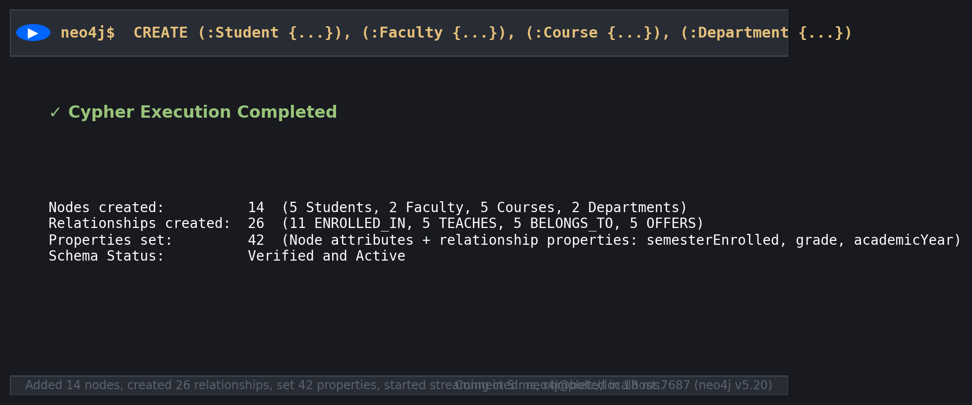
Observation: Execution verified: 14 nodes created, 26 relationships established, and 42 entity/edge properties set successfully.
• Task 4: Complete University Knowledge Graph Visualization
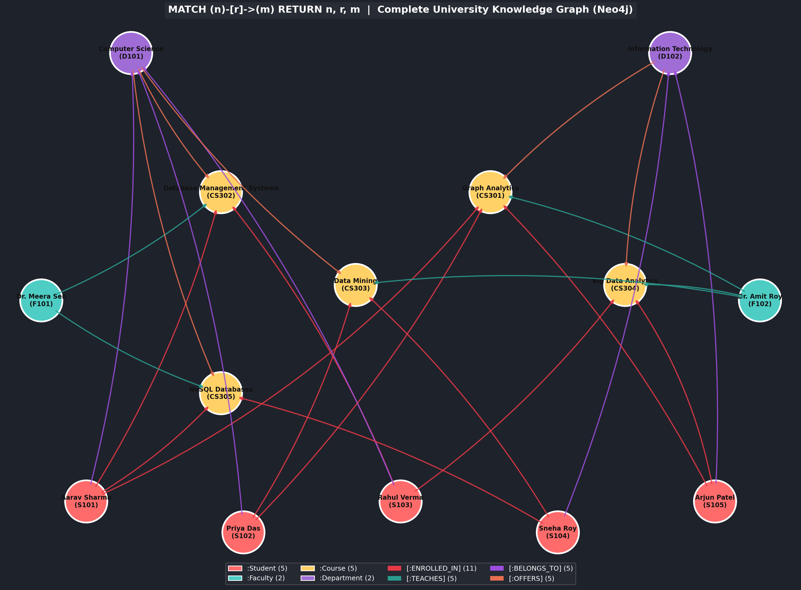
Observation: Complete property graph rendering showing 5 Students, 2 Faculty, 5 Courses, and 2 Departments interconnected by directed relations.
• Task 5: Count of Nodes Belonging to Each Label
Label | NodeCount
Student | 5
Course | 5
Faculty | 2
Department | 2

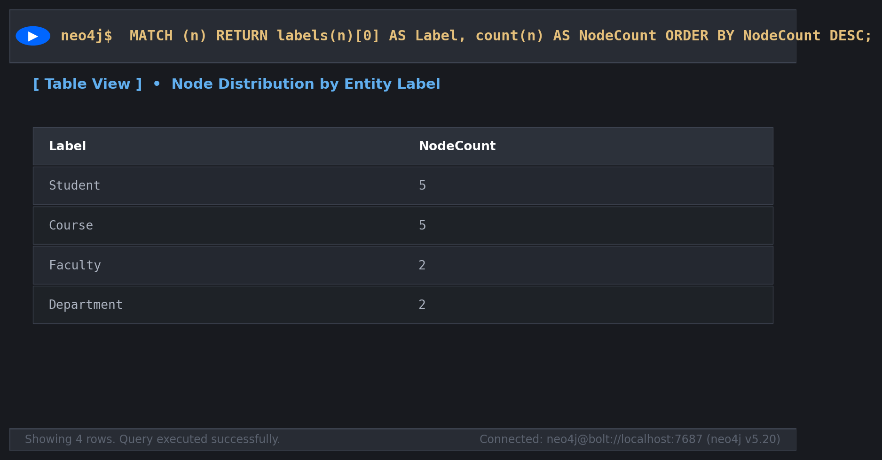
Observation: Result: Student (5), Course (5), Faculty (2), Department (2). Total nodes = 14.
• Task 6: Display All Relationship Types and Verify Directions
RelationshipType | FromNode | ToNode | Count
ENROLLED_IN | Student | Course | 11
TEACHES | Faculty | Course | 5
BELONGS_TO | Student | Department | 5
OFFERS | Department | Course | 5

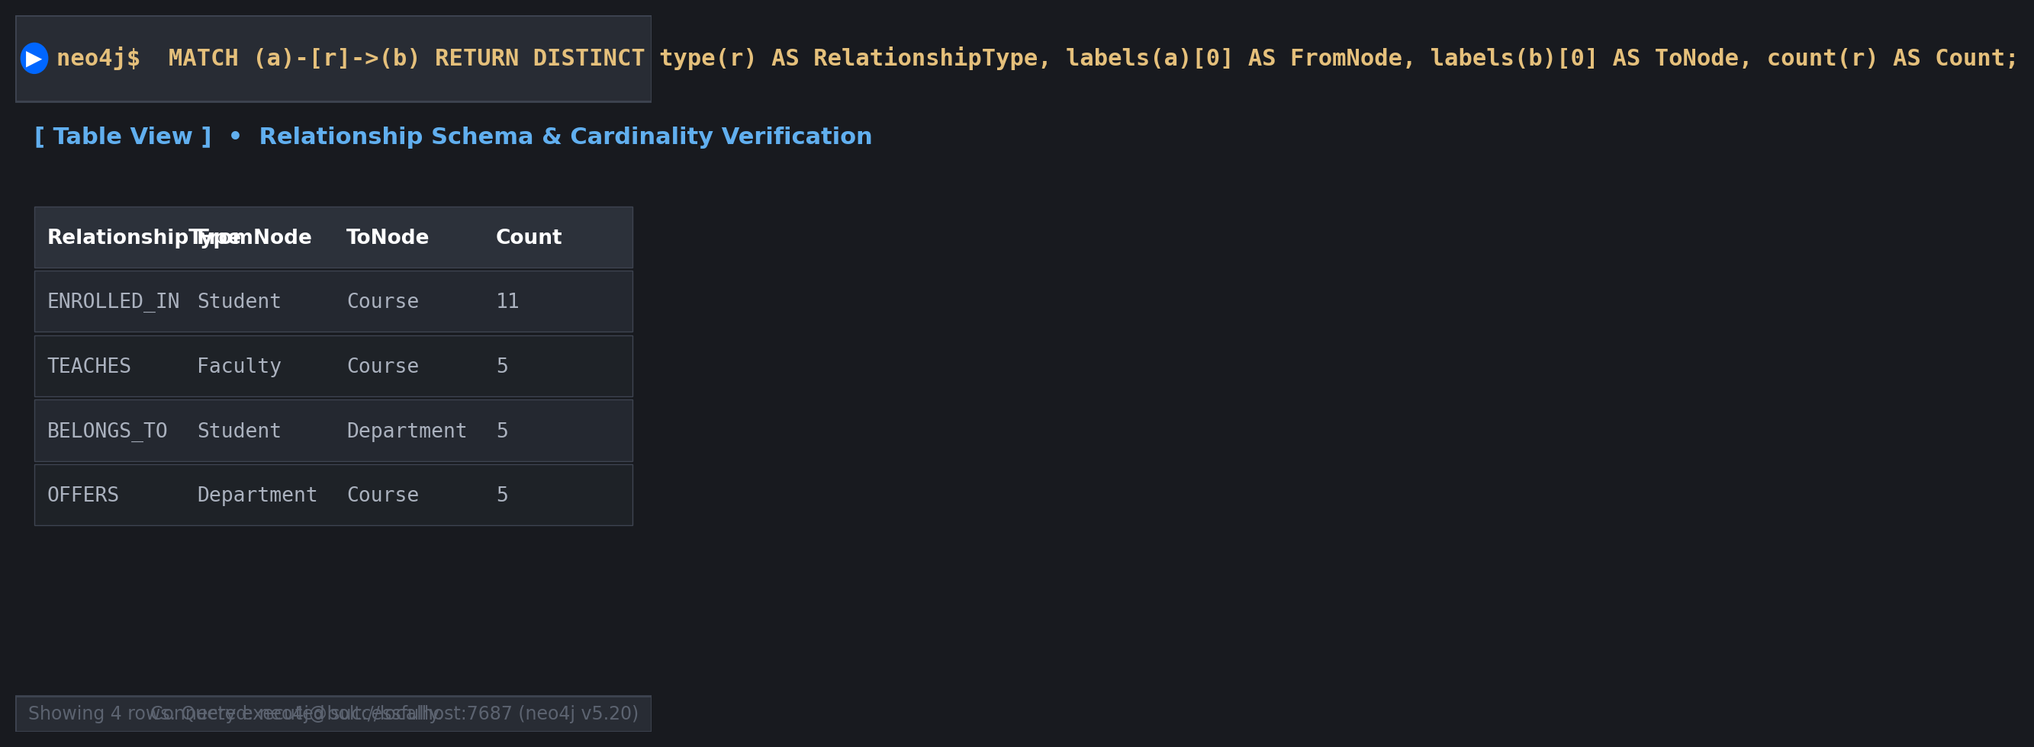
Observation: All four relationship types confirmed with correct directionality and matching schema cardinality.
• Task 7: Students Studying in Semester 5
StudentID | Name | Semester | Email
S101 | Aarav Sharma | 5 | aarav@univ.edu
S102 | Priya Das | 5 | priya@univ.edu
S105 | Arjun Patel | 5 | arjun@univ.edu

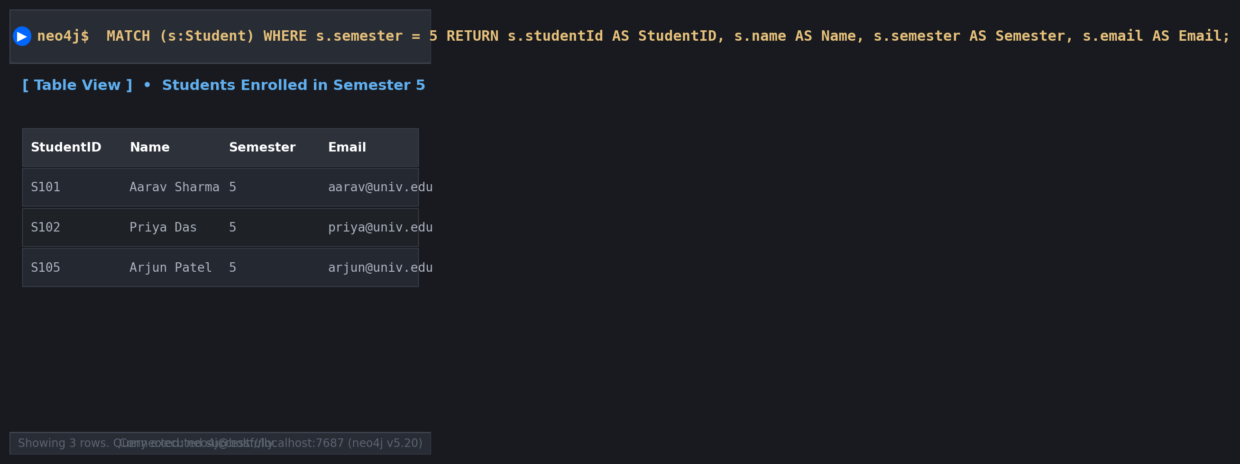
Observation: Filtering by s.semester = 5 correctly yields 3 students.
• Task 8: Courses with More Than 3 Credits
CourseCode | CourseTitle | Credits | Level
CS302 | Database Management Systems | 4 | Core
CS304 | Big Data Analytics | 4 | Advanced

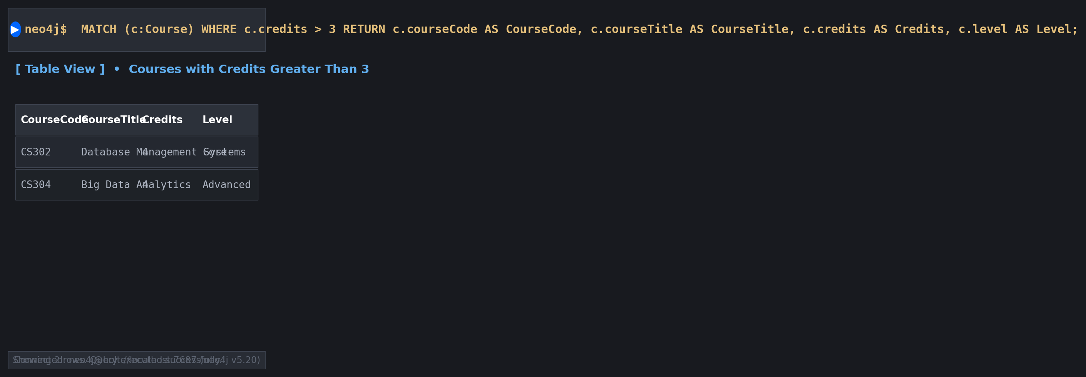
Observation: Filtering by c.credits > 3 returns CS302 and CS304 (both 4 credits).
• Task 9: Courses Taught by Dr. Meera Sen
FacultyName | CourseCode | CourseTitle | Credits
Dr. Meera Sen | CS302 | Database Management Systems | 4
Dr. Meera Sen | CS305 | NoSQL Databases | 3

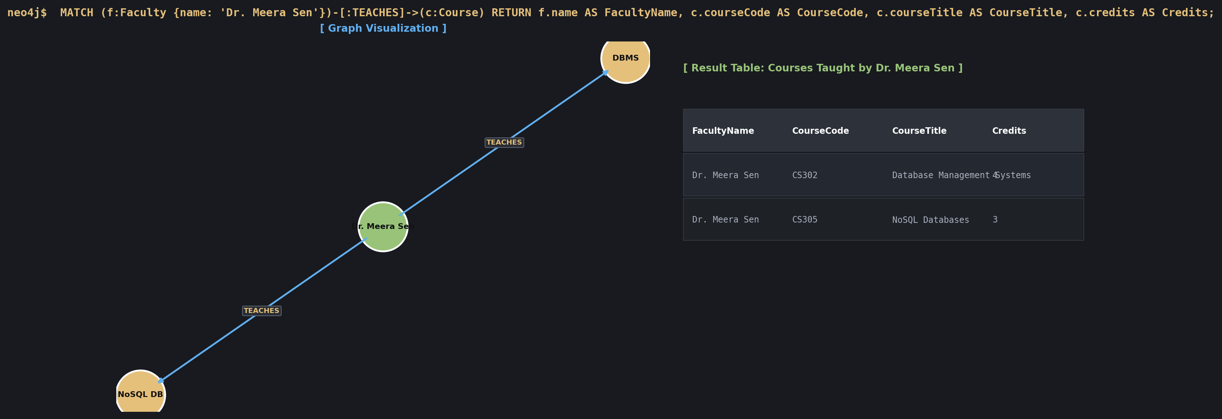
Observation: Matching (f)-[:TEACHES]->(c) returns Database Management Systems and NoSQL Databases.
• Task 10: Students Enrolled in Graph Analytics
StudentID | Name | Semester | EnrolledCourse
S101 | Aarav Sharma | 5 | Graph Analytics
S102 | Priya Das | 5 | Graph Analytics
S105 | Arjun Patel | 5 | Graph Analytics

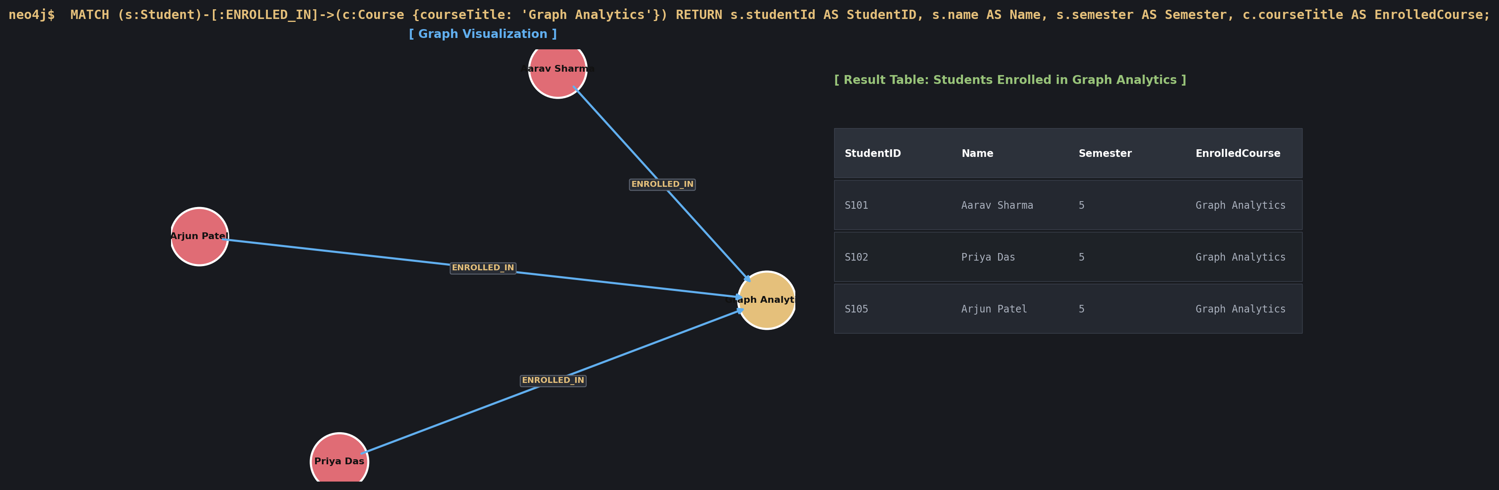
Observation: 3 students (Aarav, Priya, Arjun) are enrolled in Graph Analytics.
• Task 11: Students Belonging to Computer Science Department
StudentID | StudentName | Department
S101 | Aarav Sharma | Computer Science
S102 | Priya Das | Computer Science
S103 | Rahul Verma | Computer Science

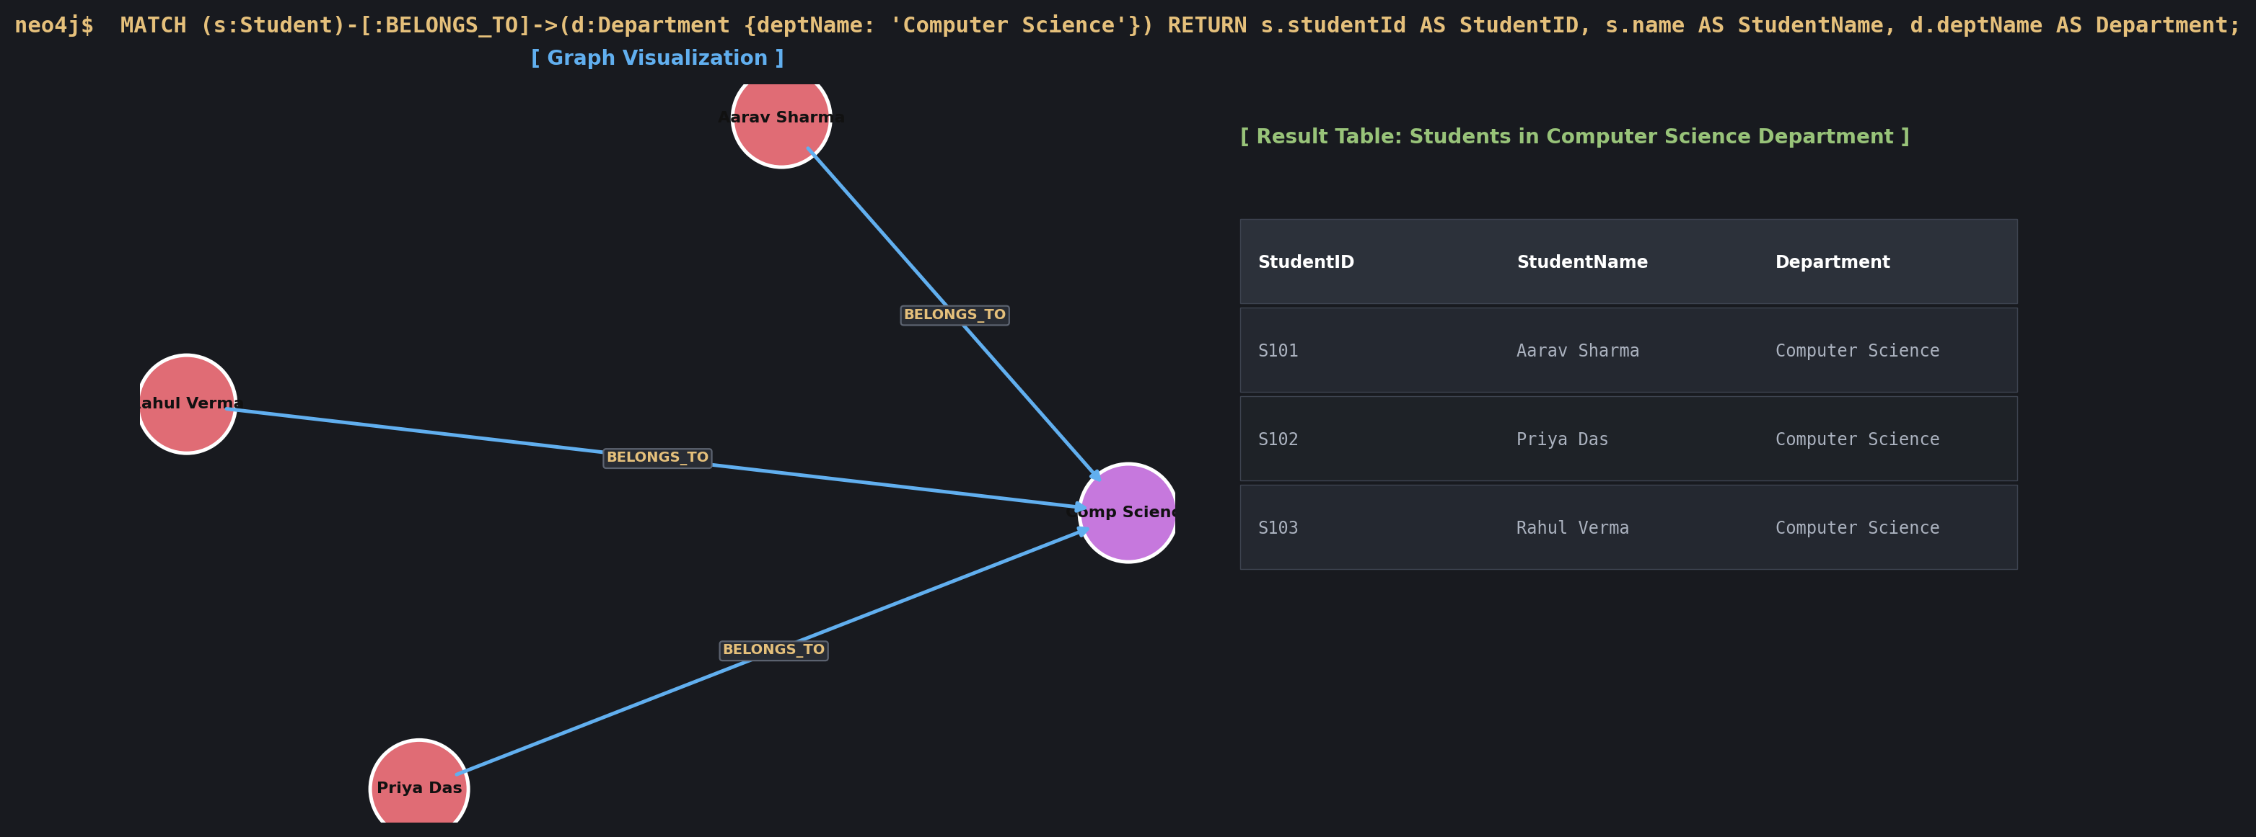
Observation: 3 students (Aarav, Priya, Rahul) are associated with Computer Science.
• Task 12: Courses Offered by Information Technology Department
Department | CourseCode | CourseTitle | Credits | Level
Information Technology | CS301 | Graph Analytics | 3 | Advanced
Information Technology | CS304 | Big Data Analytics | 4 | Advanced

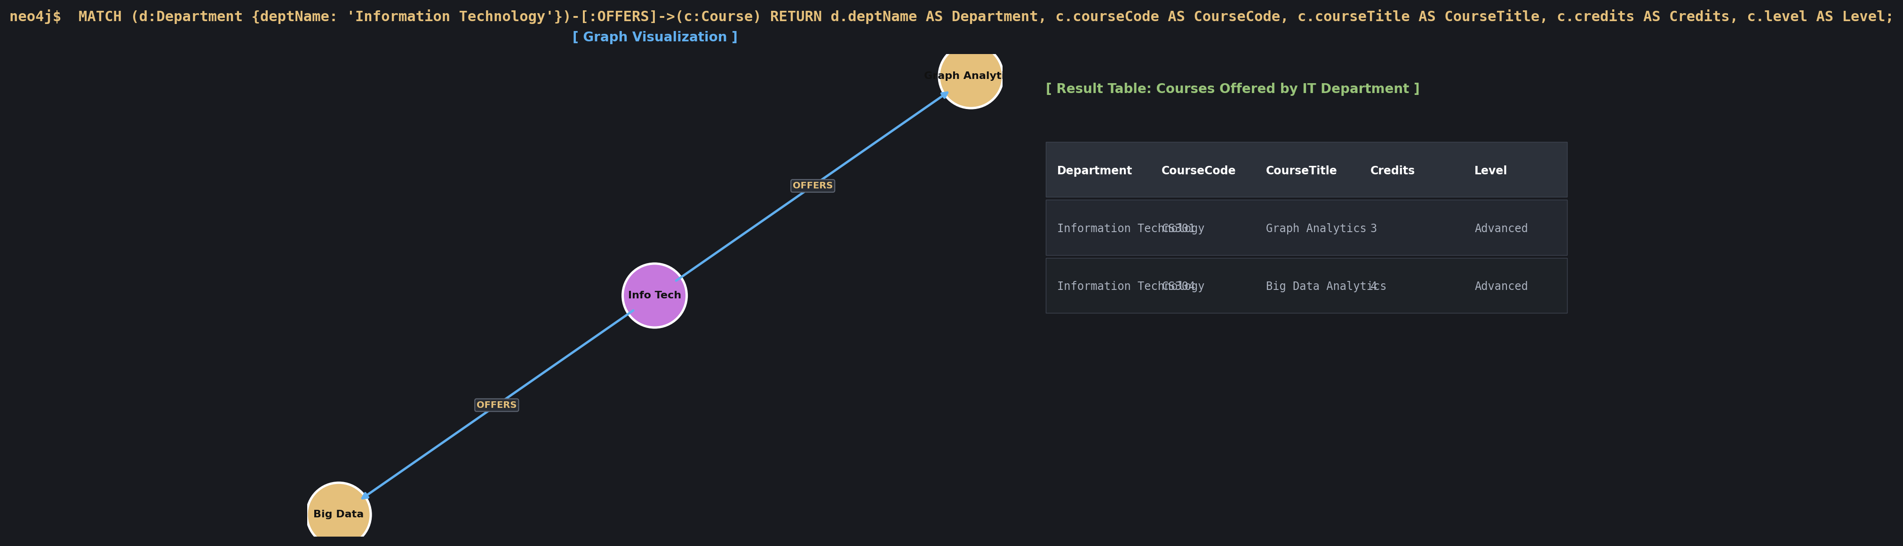
Observation: 2 courses (CS301 and CS304) are offered by the Information Technology department.
• Task 13: Students Enrolled in NoSQL Databases with Semester and Grade
StudentID | Name | SemesterEnrolled | Grade | Course
S101 | Aarav Sharma | 5 | Not Published | NoSQL Databases
S104 | Sneha Roy | 3 | Not Published | NoSQL Databases

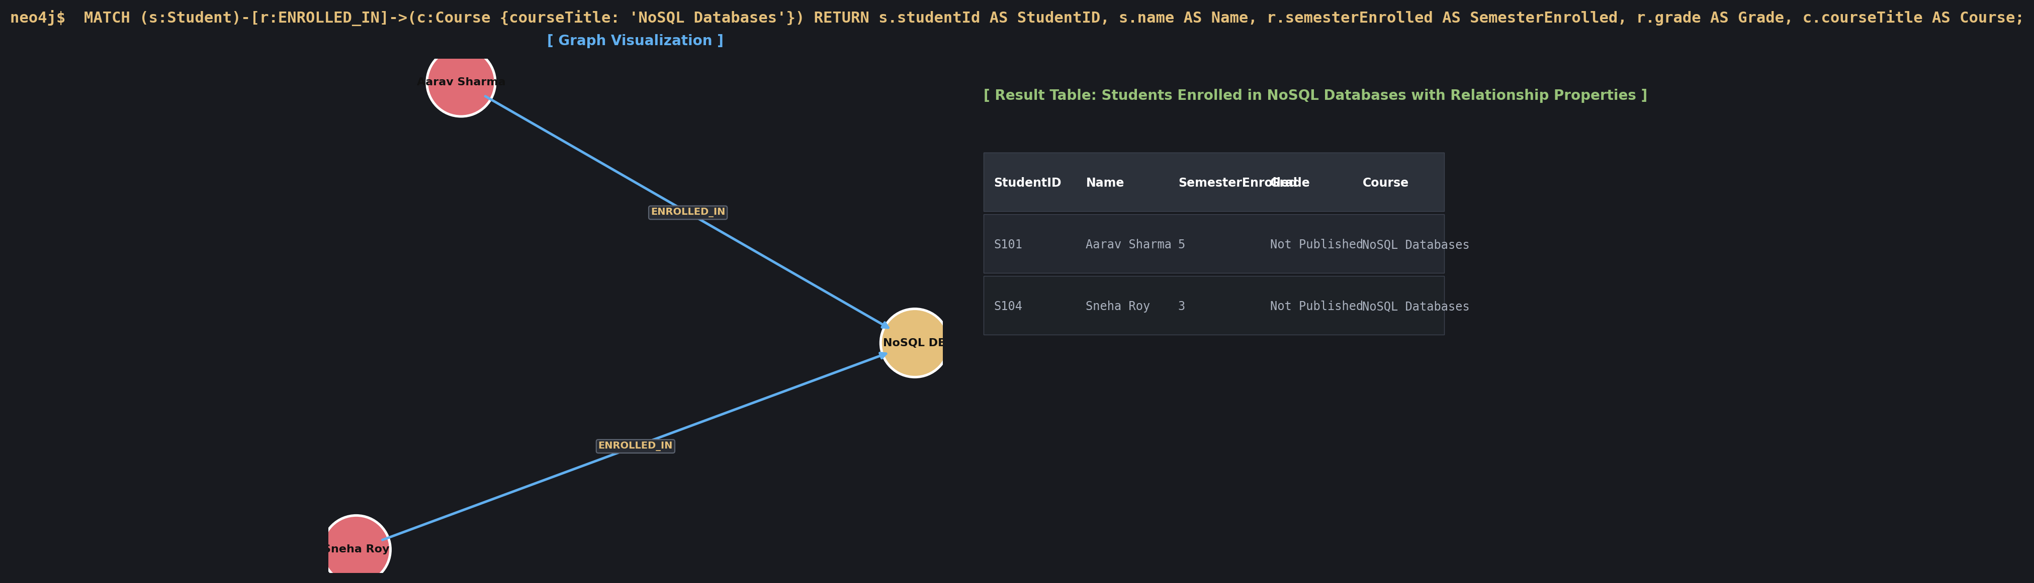
Observation: Retrieves relationship properties semesterEnrolled and grade for NoSQL Databases enrollments.
• Task 14: Students Enrolled in Both Graph Analytics and Another Course
StudentID | StudentName | OtherCourseCode | OtherCourseTitle
S101 | Aarav Sharma | CS302 | Database Management Systems
S101 | Aarav Sharma | CS305 | NoSQL Databases
S102 | Priya Das | CS303 | Data Mining
S105 | Arjun Patel | CS304 | Big Data Analytics

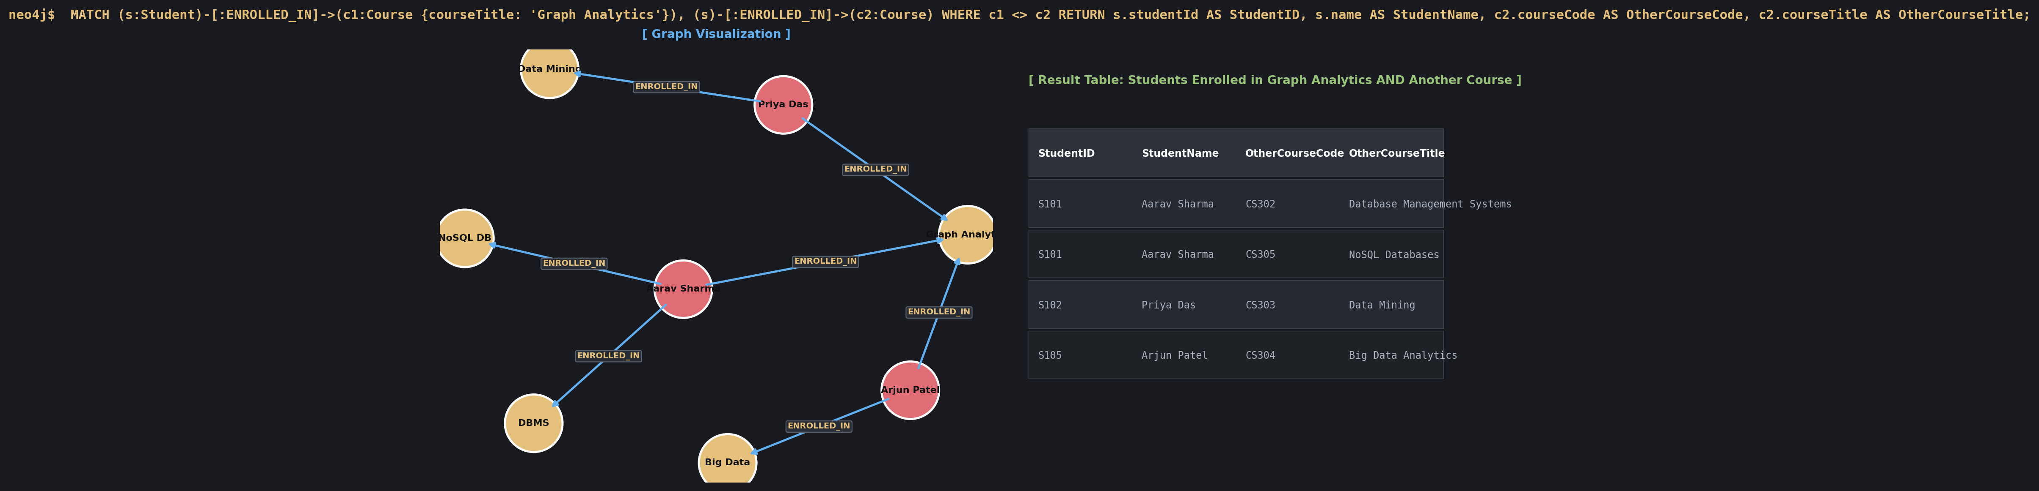
Observation: Identifies students enrolled concurrently in Graph Analytics and complementary courses.
H. Observation:
1. Property Graph Expressiveness: Modeling university relationships using Neo4j's labeled property graph model provides substantial structural clarity over traditional relational tables. Entities such as Student, Faculty, Course, and Department maintain intuitive semantic boundaries, while relationships (ENROLLED_IN, TEACHES, BELONGS_TO, OFFERS) naturally represent direct navigational pointers without necessitating foreign keys or bridge/junction tables.
2. Direct Pointer Navigation (Index-Free Adjacency): In Neo4j, traversing paths (such as identifying all courses taught by faculty within a specific department or identifying multi-course student enrollments) operates in O(k) time relative to the degree of the node rather than O(log N) indexed B-tree lookups or O(N) Cartesian joins in relational databases. This offers immense performance scalability as the student and course catalog grows.
3. Rich Relationship Properties: Cypher seamlessly allows relationship attributes (such as semesterEnrolled and grade on ENROLLED_IN, and academicYear on TEACHES). This eliminates redundant link entities and enables fine-grained temporal and evaluation queries directly on graph edges.
4. Declarative Cypher Syntax: Complex pattern matching queries—such as Task 14, where students concurrently enrolled in Graph Analytics and other courses are identified using `(s)-[:ENROLLED_IN]->(c1)` and `(s)-[:ENROLLED_IN]->(c2)` with `c1 <> c2`—are represented concisely and readably through ASCII-art inspired pattern declarations.

